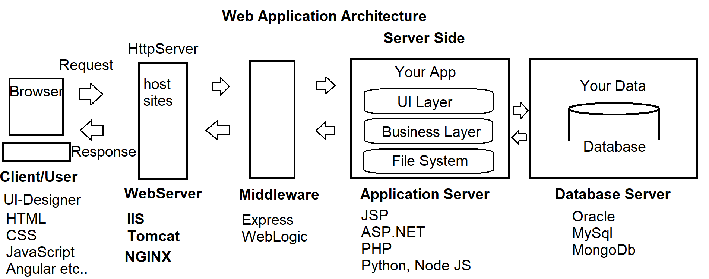

**What are the basic requirements to build an end-to-end Web Application?**

1. HTML
2. CSS
3. Client-Side Script

**JavaScript Language, JQuery Library, Angular Framework etc..**

1. Server-Side Script

**JSP, PHP, .NET, Python**

1. Middleware

**Express, Web Logic etc..**

1. Database

**Oracle, MySql, MongoDb etc..**

1. Desk Top Publishing Tools

**Photoshop, CorelDraw, Flash etc..**

1. IDE’s

**Visual Studio Code, WebStrom, Eclipse, Notepad++ etc..**

**Stack Developers**

* Java Stack
* .NET Stack
* PHP Stack
* Python Stack
* MEAN Stack

M - MongoDb Database

E - Express Middleware

A - Angular Client Side

N - Node JS Server Side

* MERN Stack

M - MongoDb Database

E - Express Middleware

R - React Client Side

N - Node JS Server Side

**What we learn in UI Technologies?**

1. HTML
2. CSS, Bootstrap
3. Client-Side Script

**JavaScript Language, JQuery Library, Angular Js, TypeScript**

1. Publishing Tools  
    **Photoshop, Flash**
2. IDE’s

**Visual Studio Code**

**We will learn how to publish live, integrate with server side and database**

**Web Terminology**

1. **Network  
   -** A group of computers connected with each other for sharing of information and resources.  
   - **ARPANET [**Advanced Research Project Agency Network**]** by US-DOD
2. **Types of Networks**- LAN [Local Area Network]  
   - MAN [Metro Politian Area Network]  
   - WAN [Wide Area Network]
3. **Internet**- It is a wide area network that connects computers all over the world.  
   - No restriction is access.  
   - Any user can access information from anywhere.
4. **Web  
   -** It is a portion of Internet with restricted access.  
   - Introduced in early 1990’s by **Tim Berners Lee** [Father of Web - HTML]  
   - Web standards are maintained by **W3C and WHATWG  
   - World Wide Web Consortium [w3c.org]  
   - Web Hyper Text Application Technology Work Group [whatwg.org]**
5. **Web Server**- It resembles both hardware and software.  
   - It satisfies the client request by sending and receiving data.  
   - It handles the client request, It process the request and sends response back.  
   - Popular Open Source Web Server Software:  
    **Tomcat, IIS [Internet Information Services], NGINX, Node.js, Lighttpd**- We use local web servers for hosting websites, and managing websites.  
   - We use live servers for production and go live. So that it can be accessed from any location.

**Setup Environment for Local Web Server**:

* Windows OS have a webserver called IIS
* Mac, Linux, OSX – download tomcat, IIS

**Windows IIS Web Server:  
-** Open windows control panel

**-** Administrative Tools  
- IIS [Internet Information Services Manager]  
  
**You can Add IIS to Windows**- Control Panel  
- Programs and Features  
- Turn Windows Features On or OFF  
- Select “Internet Information Services”  
  
**Test your Local Web Server [IIS]**- Open any browser  
- Type the URL : <http://localhost> or <http://127.0.0.1>

**6. Web Site**

**-** Web Site is a virtual directory of Web Server.

- Site [Location] on Web Server

- It provides access to the resources.

**Creating a new Web Site on Local Server:**

* Open your local web server “IIS” [Internet Information Services]  
  **Run 🡪 Inetmgr**
* Expand “Local Computer” [http://localhost]
* Expand “Sites” folder
* Right Click on “Default Website”
* Select the option “Add Virtual Directory”

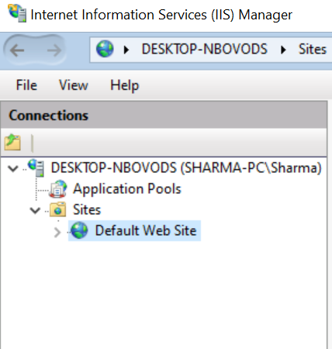

* Specify the following details for a new Website

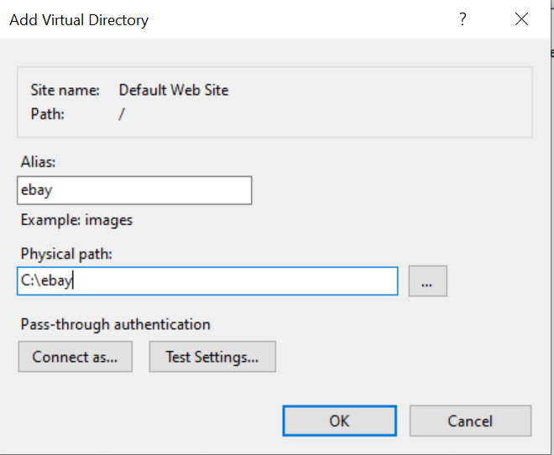

alias [Web site] Virtual Path : ebay

Physical path: : C:\ebay

* Open any browser and test your website

<http://localhost/ebay>

(or)

<http://127.0.0.1/ebay>

### Note: Initially it returns HTTP Error 403.14 - Forbidden

* You have to maintain resources for your website: Images, Documents etc.
* Go to your website Physical Path: **C:\ebay**
* Add folders and Files
  + Images
    - Banner1.jpg
    - Banner2.jpg
  + Docs
    - Cssdemo.pdf
* Your can request resource by using the virtual path  
  <http://localhost/ebay/Docs/cssdemo.pdf>

<http://localhost/ebay/Images/banner1.jpg>

* We have to provide an UI [User Interface] so that user can interact with the resources of our website.
* The UI is designed by using a **Hyper Text Document,** which is known as **“Web Page”.**

**Hyper - Greek - Beyond**

**Hyper Text - Beyond Text**

**7. Web Page:**

- It is a Hyper Text Document that provides an UI for user in order to interact with the resources of website.

- Web Pages are classified into 2 Types

a) Static Page

b) Dynamic Page

Static:

* It is continuous memory.
* The memory allocated for first request will continue of all other requests.
* Occupies more memory
* Static Page contains same response to send across any number of requests.
* Usually static pages have extension
  + .html home.html
  + .htm about.htm

Dynamic:

* It is discreet memory.
* Not continuous
* Memory newly allocated for every request.
* Less memory
* Dynamic page sends a response customized for every client request.
* Usually dynamic pages have extension
  + .jsp
  + .php
  + .aspx
  + .asp

**8. Web Application**

**-** A Website comprises of only static resources.

- A Web Application comprises of both static and dynamic resources.

1. **Blog / Micro Blog / Vlog:   
   -** Blog [Web Log] is like journal or internet.  
   - Blog is maintained by individual user and updated periodically.  
   - **Blog is Free**

**Ex:** blogger.com [for creating free blogs]

1. **WIKI [**Quick - Hawain] : A wiki allows any user to edit its content.

**Ex:** WikiPedia [Quick Reference for Encyclopaedia] – Anyone can edit.

Google Maps

1. **Podcasting:** It allows to upload and broadcast media [Audio/Video] onto other devices.

**Ex:** YouTube, Windows Media Player, ITunes

1. **Widgets:** Widget is a gadget for Web Site or Application. It is an application running in another application.

**Ex:** Currency Converter, EMI Calculator, BMI Calculator

1. **Web Browser:** It is software tool to access the resources from a webserver. The popular web browsers are: Chrome, FireFox, Edge, Chromium, IE etc..
2. **Web Debugger:** It is tool provided for web developers and designers to track the performance of page and identify the error or bugs. Every browser have a debugger, which you can invoke using “F12” function key.

EX: Flidder, Postman etc.

1. **URL and URI:**- URL is Uniform Resource Locator  
    It is the virtual path generated by a web server in order to access the resources from a web site.

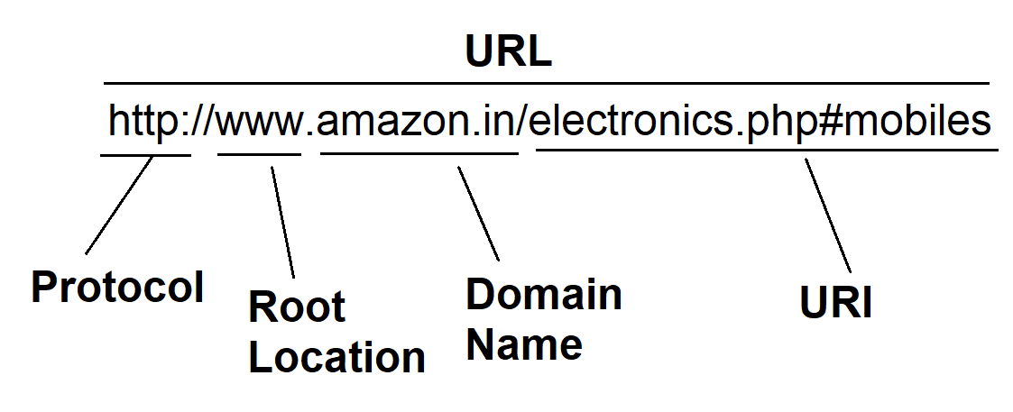  
- URI is Uniform Resource Identifier

**Protocol:** It defines a set of rules for communication in network. Computers in different networks communicate by using various rules.

Web - Http, Https (secured)

Intranet - File, FTP

Messaging - MSMQ

Email - SMTP

Internet - TCP/IP

**WWW:** World Wide Web – Specifies that the content is accessed via webserver.

HTML